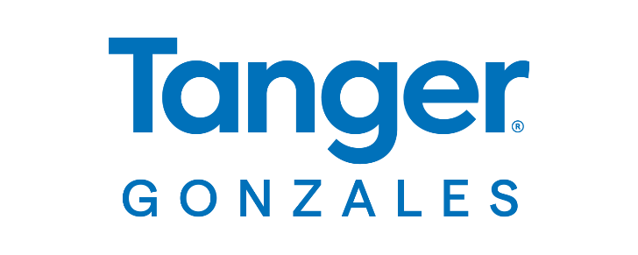

**FOR MORE INFORMATION:**

Caroline Day

BRAVE Public Relations

404.233.3993

[cday@emailbrave.com](mailto:cday@emailbrave.com)

**FOR IMMEDIATE RELEASE**

**Tanger Outlets Gonzales Welcomes Columbia Among New Store Openings***Outlet shopping destination adds top brands and relocates two shopper-favorites*

**GONZALES, La. (Aug. 26, 2024) –** Ascension Parish residents are gaining new brands to shop at **Tanger Outlets Gonzales** with this fall’s addition of **Columbia**, a retail leader for outdoor enthusiasts, and the recent opening of **Rally House**, a go-to destination for local sports fans.

The openings complement more than 50 premier stores at the open-air center, including Nike, Crocs and the newly opened **Victoria’s Secret.** Popular brands **J. Crew Factory** and **Southern Marsh** have also reopened in new locations with expanded retail space.

“We are thrilled to announce the additions of Columbia and Rally House to our shopping center, along with the enhancement and relocation of two beloved stores," said Angela Lafleur, General Manager/Marketing Director at Tanger Gonzales. "These changes elevate our retail mix, providing shoppers an even better guest experience with a greater variety of options.”

For more than 80 years, **Columbia** has developed innovated products and technologies with one simple goal:  To unlock the outdoors for everyone.  Based in the ever-inclement Pacific Northwest, innovative products are developed and rigorously tested in a variety of weather.  The company continues to adhere to founder Gert Boyle’s mantra, “It’s perfect.  Now make it better.” Opening this fall, the 7,600-square-foot space will offer shoppers outdoor apparel, footwear and equipment.

Specialty sports store **Rally House** showcases 9,000 square feet of athletic apparel, gifts, home decor and more. Now open next to Tommy Hilfiger, Rally House features a collection of area NCAA, NFL, MLB, NBA, NHL and MLS team gear as well as gifts and merchandise celebrating local brands, destinations and landmarks. ​

Combining modern classics with character to create timeless, sophisticated looks for every occasion, shopper-favorite **J. Crew Factory** offers men’s, women’s, and children’s clothing, shoes and accessories in a new 6,000-square-foot space next to Samsonite. The relocated store will showcase the brand’s signature shorts, Rollneck sweaters, dresses, well-tailored suits, loungewear and more to ensure the perfect blend of comfort and style for every budget.

Next to Guess Factory Store, **Southern Marsh** has also relocated to a newly renovated 4,000-square-foot space within the center. The brand continues to offer high-quality preppy clothing and southern-inspired styles for men, women and youth, complemented by stylish accessories for your home and family.

**About Tanger Gonzales:**Tanger Gonzales is Gonzales’ upscale, open-air outlet shopping destination, featuring a coveted collection of top brands and local shops. The 321,000-square-foot center features more than 50 premier outlet stores offering real style and real savings every day. Shopper-favorite brands at Tanger Gonzales include Bath and Body Works, Coach, Michael Kors, Nike, Old Navy, Polo Ralph Lauren and Victoria’s Secret (coming soon). For a full store listing and map, as well as directions, events and scoop on the latest sales, visit [tanger.com/gonzales](https://www.tanger.com/gonzales), download the Tanger App or connect on [Facebook](https://www.facebook.com/TangerOutletsGonzales) and [Instagram](https://www.instagram.com/tangeroutletsgonzales/). Guests can also access the ultimate shopping experience by joining [TangerClub](https://www.tanger.com/tangerclub), Tanger’s exclusive loyalty program, for curated offers and rewards.